Ex. No. : 6
Date:

AIM:

SELECT with various clause – BETWEEN, IN, Aggregate function

To retrieve records from the Employee and Department tables using SELECT statements with BETWEEN, IN, and Aggregate Functions.

DESCRIPTION:

The SELECT statement is used to retrieve data from one or more tables in a database. It allows users to display selected columns or complete records from a table.

In the Employee Database, the BETWEEN operator is used to retrieve records that fall within a specified range. The IN operator is used to compare a value with multiple values in a list. Aggregate functions are used to perform calculations on a group of records and return a single result.

These operators and functions help in filtering, summarizing, and analyzing employee information efficiently.

BETWEEN operator:

SELECT column_name

FROM Employee

WHERE column_name BETWEEN value1 AND value2;

IN operator:
SELECT column_name
FROM Employee
WHERE column_name IN ('value1','value2');
Questions:

IN & BETWEEN
- List the type of the courses “Statistics” and “Programming”
- The instructor wants to know the CourseNos whose scores are in the range 50 to 80

AGGREGATE
- COUNT() – Counts the number of records.
- SUM() – Calculates the total of numeric values.
- AVG() – Calculates the average value.
- MIN() – Finds the smallest value.
- MAX() – Finds the largest value.

OUTPUTS:
IN & BETWEEN
1)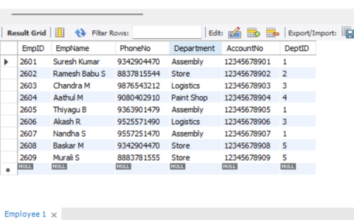

2)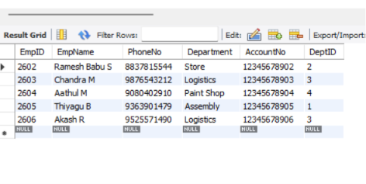

AGGREGATE
1)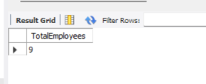

2)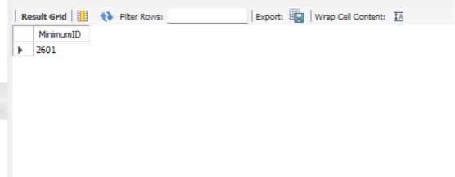

3)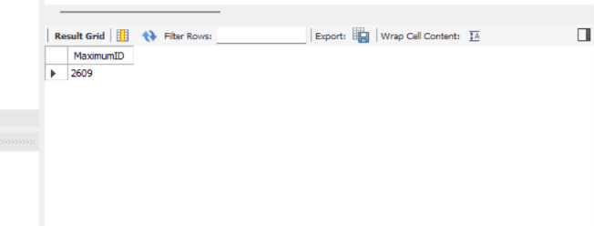

4)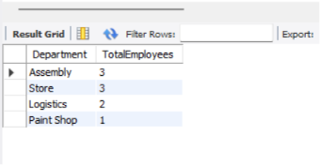

5)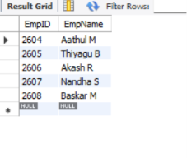

6)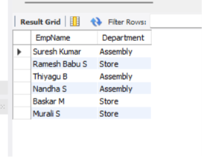

7)\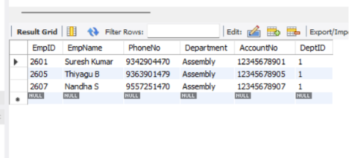

RESULT:

The records from the tables are displayed using SELECT commands with WHERE Clause and Pattern matching.

